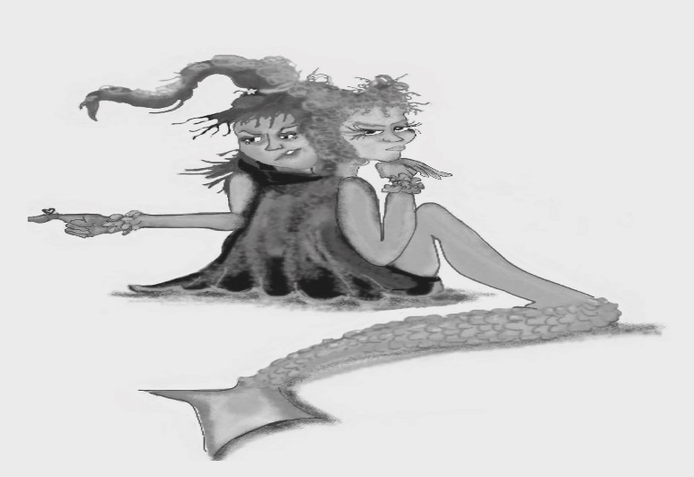
Sprite of Bad Stories (SoBS) sees the worst in everyone and everything. She loves to make the most of when things go wrong. This makes you feel miserable and hopeless.

Figure 11.2 Sprite of Bad Stories
Photocopiable: Circle Solutions for Student Wellbeing 3e Sue Roffey, 2020 (SAGE)

