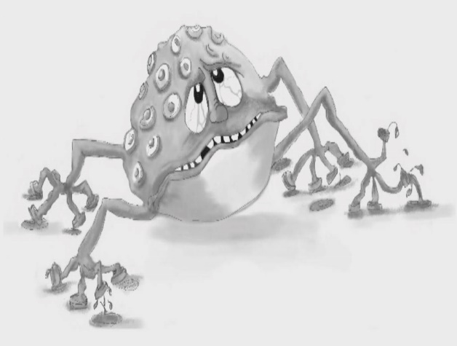
Worry Wart – everyone has a Worry Wart, at least sometimes. This is the voice that tells you everything that might go wrong (it usually doesn’t) and makes you feel anxious and scared to try new things or even do your best with familiar ones.

Figure 11.4 Worry Wart
Photocopiable: Circle Solutions for Student Wellbeing 3e Sue Roffey, 2020 (SAGE)

