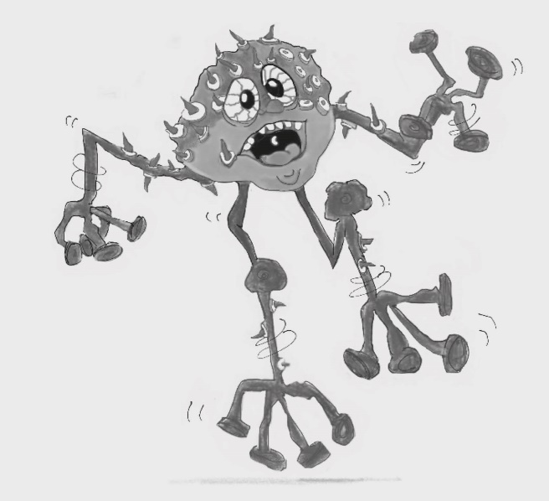
When Worry Wart gets out of control, it can turn into Panic Monster. This can stop you thinking straight.

Figure 11.5 Panic Monster
Photocopiable: Circle Solutions for Student Wellbeing 3e Sue Roffey, 2020 (SAGE)

