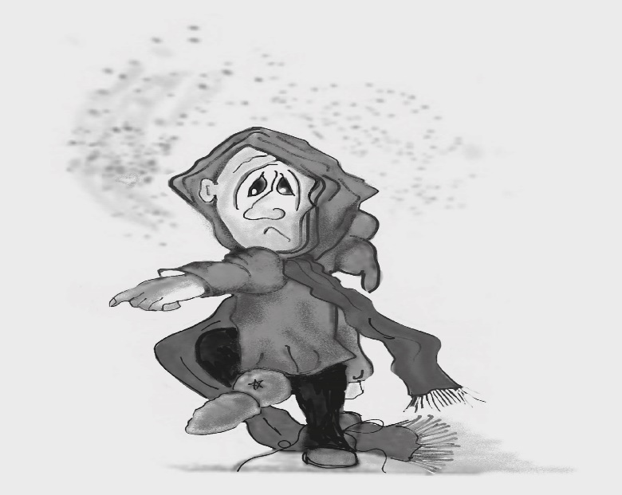
Doom Merchant catastophizes by using the words ‘Always’ and ‘Never’, such as ‘It is always raining’ and ‘We never have any fun’. When something bad happens once, you begin to believe it happens all the time – perhaps because you are a bad person. This can make you feel angry, resentful or just downright miserable.

Figure 11.6 Doom Merchant
Photocopiable: Circle Solutions for Student Wellbeing 3e Sue Roffey, 2020 (SAGE)

