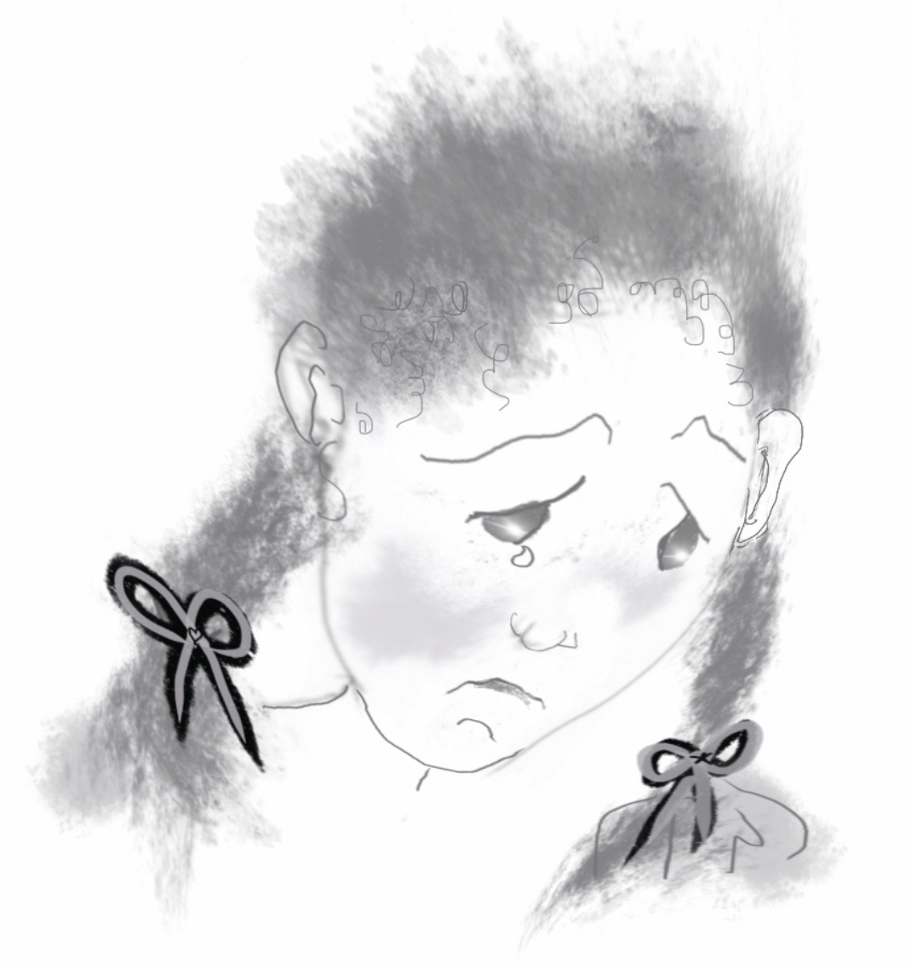

Figure 7.2 Child crying
Photocopiable: Circle Solutions for Student Wellbeing 3e Sue Roffey, 2020 (SAGE)

