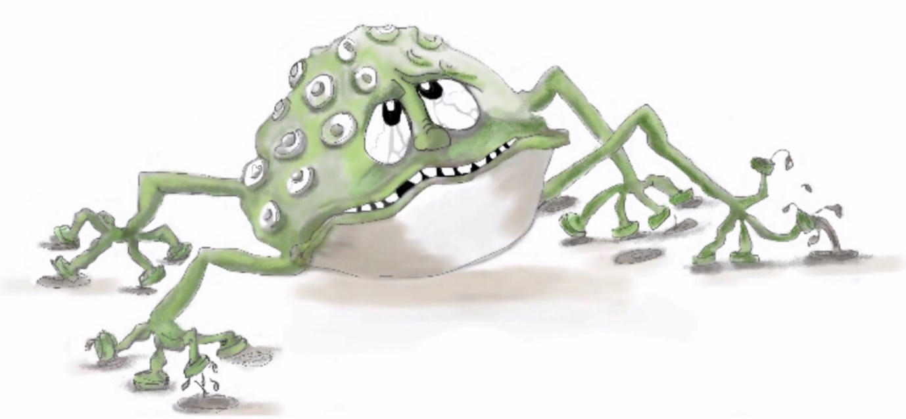

Figure 7.3 Worry Wart
Photocopiable: Circle Solutions for Student Wellbeing 3e Sue Roffey, 2020 (SAGE)

