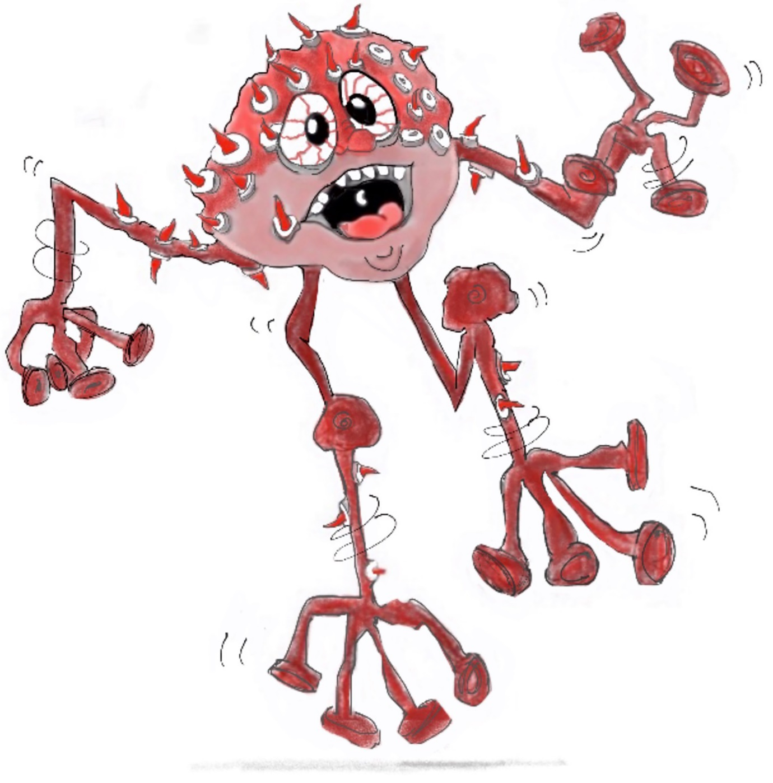

Figure 7.4 Panic Monster
Photocopiable: Circle Solutions for Student Wellbeing 3e Sue Roffey, 2020 (SAGE)

