Tutorial 5.2

Depicting a Nonlinear Logic Model
The logic models in Chapter 5 of Case Study Research and Applications (6th ed.) all depict linear sequences of events. However, real-world events vacillate and intertwine in a more complex manner. The linear logic model may still have merit, because a sequence can be linear in the long run, smoothing over any short-term vacillations. However, Figure 5.A might help if you want to depict the nonlinear complexity explicitly (Yin & Davis, 2006, 2007).
The figure has four panels, each with a title at the top and a time interval, t1 to t4, in the lower right-hand corner. In each panel, the group of concentric circles represents the same organization but whose reform status fluctuates vertically from panel to panel. Thus, at t1, the circles are at their lowest, representing the organization at its lowest reform status, whereas t3 shows the organization at its highest status. The flexibility along the vertical dimension permits the reform status to be represented nonlinearly, so for illustrative purposes, a regressive reform status is shown at t4. In this manner, the progressive and regressive shifts can be depicted over any amount of time and even shown in motion, graphically.
In this example, the organization is a school system. The various elements within the school system appear as lettered objects within each group of concentric circles (the lettered objects are decoded in the “key” at the bottom of Figure 5.A). The theory of education reform posits that system reform will advance as the elements become aligned (depicted by their shifting from the periphery to the center of the concentric circles over time). The vertical scale is student performance, with the theory claiming greater reform to be associated with improved student performance. As a result, the theory also stipulates that the desired reform needs to affect an increasing number of units within the organization, in this case the schools (represented by the flags) within the school system.
A similar nonlinear logic model can represent a business or any other organization undergoing coordinated operational changes aimed at transforming the organization and its culture—and in business, even its name (see Yin, 2012, chaps. 9 and 12 for a case study of a single firm and then the cross-case analysis of a group of transformed firms).
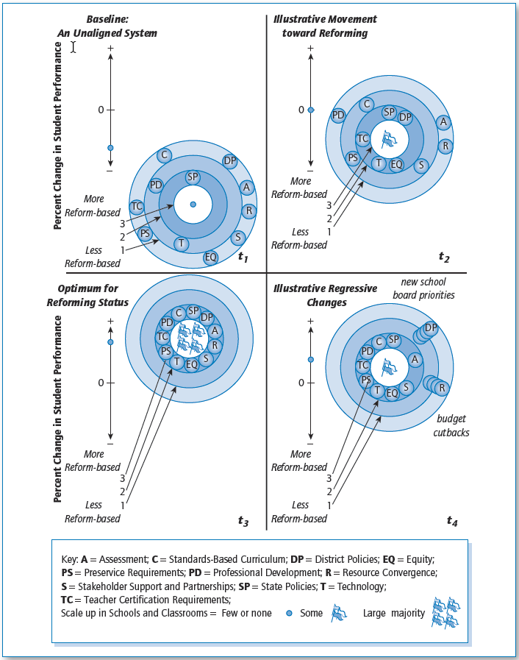
Figure 5.A Hypothetical States of an Education K-12 Reforming System. Source: Yin and Davis (2007).

Briefly Annotated References for Tutorial 5.2
Yin, R. K. (2012). Applications of case study research (3rd ed.). Thousand Oaks, CA: Sage. Contains case studies on comprehensive transformation within business firms.
Yin, R. K., & Davis, D. (2006). State-level education reform: Putting all the pieces together. In K. Wong & S. Rutledge (Eds.), Systemwide efforts to improve student achievement (pp. 1–33). Greenwich, CT: Information Age Publishing. Describes comprehensive education reform.
Yin, R. K., & Davis, D. (2007). Adding new dimensions to case study evaluations: The case of evaluating comprehensive reforms. In G. Julnes & D. J. Rog (Eds.), Informing federal policies for evaluation methodology (New Directions in Program Evaluation, No. 113, pp. 75–93). San Francisco: Jossey-Bass. Discusses the education issues related to the illustrative nonlinear logic model.

